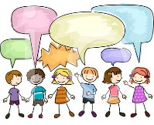
Personal, Social and Emotional Development
- I am able to separate from my close carers and explore new situations.
-I am building relationships with adults and peers.
- I can express a wide range of feelings in my interactions with others.
- I enjoy a sense of belonging by being involved in daily tasks.
-I have confidence to speak to others and ask for help.

Mathematics
-I am beginning to point at or touch each item, saying one number for each item.
-I can quickly recognize a group of up to 3 objects without having to them individually (subitising).
-I can explore the composition of numbers 0-5.
-I can sort items in different ways
-I can find, continue and create repeating patterns
I can compare two groups of objects
Core Texts
Starting School, The Colour Monster, Beegu, Goldilocks and the three bears,Big book of families, Little Red Hen,
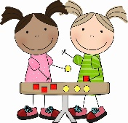
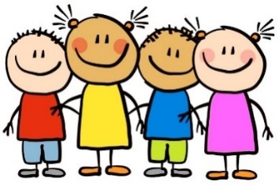
Understanding of the World
- I can talk about past and present events in my own life and in the lives of my family, eg, for the Grandparents Afternoon Tea Party or when sharing ‘All About Me’ books.
-I can name and describe people who are familiar to me.
- I join in with customs and routines
- I can talk about some festivals-Harvest
- I can observe and comment on the weather and seasonal change, eg. when discussing the whole class calendar or during Forest School and outdoor play.

Communication and Language
-I can listen and join in with rhymes and songs.
- I can join in with repetitive refrains.
- I can listen to and follow simple instructions’
- I can talk about things that are important to me- sharing All about me book, tapestries, show and tell.
- I can answer and ask questions - who, what, where, why, when.

Me and my community
Expressive Arts and Design
- I can explore different materials freely, to develop ideas about how to use them and what to make (with support if needed).
-I am beginning to draw simple representations, eg. of objects, scenes, self portrait using a mirror, etc.
-I can investigate marks and patterns when drawing.
-I can use natural objects for printmaking, eg. printing with harvest fruit and vegetables.
-I can engage in pretend play- role play or small world.

Physical Development
- I am developing my core muscle strength.
- I can show preference for a dominant hand.
-I can use a comfortable grip with good control when holding pens and pencils.
-I can create lines and circles pivoting from the shoulder.
- I am developing my ability to dress and undress, using fastening, fancy dress, dolls
- I am beginning to use one handed tools and equipment, e.g using a paint brush, pencil, tweezers

Literacy
- I recognise and make attempts to write my name
- I can hear the initial sound in a word.
-I am beginning to orally blend and segment simple words.
-I can handle books with care and hold them using the correct orientation, reading from front to back.
-I can continue a rhyming string and identify alliteration.
-I can make marks to convey meaning.
- I can write the initial sound in a word.
- I can talk about characters in a story and how they might be feeling.

Class R – Autumn 1 2026



